



**MCSP - 060**

**Exam Portal**

**By**

**Shubham Yadav**

**Enrolment No: 190749154**

**Under Guidance**

**Of**

**Kaptan Singh**

**Submitted to the School of Computer and Information Sciences, IGNOU in partial fulfilment of the requirements**

**For the award of the degree**

**Master of Computer Applications (MCA) 2020-21**

**Indira Gandhi National Open University Maidan Garhi**

**New Delhi – 110068**

# 

**Table Of Content**

**S.NO. Content Page No**

1. **Introduction** 4
2. **Objective** 4
3. **Project Category** 5
4. **Tools** 5
5. **Hardware and Software Requirement specifications** 5
   1. Hardware Requirement 5

5.2 Software Requirement 5

1. **Problem Definition** 6
2. **Requirement specifications** 6

7.1Detailed Functional Requirement 6

7.2 Technical Specification 7

**8**.  **Project Planning And Scheduling** 7

8.1 Gantt Chart 7

8.2 Pert Chart 8

* + 1. **9. Scope Of The Solution** 8..9
    2. **10. Analysis** 9
    3. 10.1 Data Flow Diagram 9..11
    4. 10.2 E-R Diagram 12
    5. 10.3 Activity Diagram 13
    6. 10.4 Class Diagram 14
    7. 10.5 State Diagram 15

**11. Database Design** 16

* + 1. 11.1 User Module Schema 16

11.2 Exam Module Schema 16

11.3 Database Table 16

11.3.1 User Table 16

11.3.2 Role Table 17

11.3.3 User Role Table 17

11.3.4 Category Table 17

11.3.5 Quiz Table 17

11.3.6 Question Table 17

**12. Implementation Methodology** 18

**13. List Of Reports That Are Likely To Be Generated** 18

**14. Process Logic** 19

14.1 Login 19

14.1 Register 19

**15. Implementation Of Security Mechanisms Of Various Level** 20

**16. Future Enhancement** 20

**17. Bibliography** 21

1. **Introduction**

**Exam Portal** project could be a web portal which is developed or implemented in java domain or platform. This project is helpful for students to practice different mock examinations from this site. In current generation lots of the examinations like

Java, python, JavaScript etc. is conducted through online system. This project will help students to get practiced to online examination method by taking mock tests from this web portal. Online examination portal is implemented in & modules student examination module and examination admin module. Admin module will add multiple courses under different branches so students can easily know about test details. Student examination module students must be register with application and choose interested courses and participate in the online test.

**(2) Objective**

The purpose of this project is to develop **Exam Portal**. This is a web based **Exam Portal** System which will help in conducting the Online Mock Tests. The purpose of this **Exam Portal** project is to provide a web application which will considerably reduce the time required to give the exam and know the results. This project will provide an efficient platform both for the students and programmer etc., by enabling examinations to be taken online and to evaluate their existing knowledge.

Some of the objectives achieved by site are as follows: -

* **Easy to use Interface**

This is among one of the most critical features, responsible for the Survival of the software in the market. Actually what happens, the Software created with huge amount of functionality could not attract the Customer, just because of the poor graphical interface.

* **Global Platform**

The site for Online Examinations is an expert application for Providing a Global platform for all sort of user, who can participate through this application.

* **Faster Accessibility**

The site for Online Examinations use the most important server methods As a result of this accessing the server for fetching the information, responding to the server could be easily and efficiently

Been done.

.

**(3)Project Category**

* **RDBMS Project:** this project is based on data Operation (CRUD).

This will store question, quiz, category, and user data in database

And perform many operation as per user reaction or activity.

**(4)Tools**

* **Integrated Development Environment (IDE):**  Visual Studio Code
* **Web Server:** Apache Tomcat 10
* **Database :** MySQL 8
* **Web Browser:** Chrome, Firefox, Edge.
* **Internet Connection:** Internet Must Be Required.

**(5)Hardware and Software Requirement specifications**

**(5.1) Hardware Requirements:-**

* **Processor** : Intel i3/i5
* **RAM :** 1 GB Ram
* **Cache Memory :** 512 KB Cache Memory
* **Physical Memory :** Hard disk 250 GB

**(5.2) Software Requirements: -**

* **Web Technologies:** Spring Boot, Hibernate
* **Front** **– End Technology:** Angular JS
* **Language** : JAVA
* **Database** : MySQL
* **Web Server**  : Spring Boot Dedicated Apache Tomcat Server
* **Operating System** : WINDOWS 10

**(6) Problem Definition**

Presently, if the programmer or student do not have any platform to check their knowledge level

And competency. **Exam Portal** such a portal help them to elaborate their knowledge and skills.

**Exam Portal** is to offer a quick and easy way to appear for the exam through different type of mock test are available there. It also provides the results immediately after once the exam is completed or summited. The user have to enter a valid user id and password to attend the exam. This examination contains multiple choice questions and appropriate number of options. There are no limitations on number of options and it can be randomized. This examination project provides time limit to finish the exam. The user can see their results after completing the exam.

Due to current pandemic situation most of the student or learner’s looking such a online solution

Rather than going physical mock test session in coaching classes or training institute so that,

This system give student or learner’s to attend mock test in online mode to check their knowledge immediately and frequently (No Limit to attempt mock test).

**(7) Requirement Specifications**

**(7.1)Detailed functional Requirements**

* **Login Module:**In this module user can login to the website by entering login ID and password. After Login the system links to Profile page.
* **Accounts Module:**The module maintains the details for each student as well as provides a facility for editing the student details and the students can change their own passwords in this module if required.
* **Examination Module:** In this module students can take the exam and submit the answers. The system can automatically create exams by randomly choosing questions from database. It provides limited time to answer the questions. When the student starts the exam the timer will start automatically and show the student how much time is left. After the exam this module will be disabled automatically and Results can be viewed immediately upon Submission.
* **Dashboard Module:**Only Administrator and Examiner can access this module. Here administrator or examiner can view student details, Marks report, examination report, etc. It has a facility to Add students details, view Student List as well as Edit student details and Also administrator can manage users details, course and subject details.
* **Question Bank Module:**Questions bank will have a program to add, modify and delete questions from subject. Here Examiner can upload questions and set valuation schemes and test duration. The questions have different attributes like subject, topic, marks, question text, options and the answer. The question can be text or image.
* **Results Module:**In this module students and examiners will get instant results. Results can also be printed as soon as the test finishes.

**Note-** Above provided module are initial and time bound. It may be changed as per requirements.

**(7.2)Technical Specification**

* **Minimum Software Requirement:**
* **Operating system**  : Windows 10
* **Front End** : JRE 1.11
* **Back End** : MY SQL
* **Server Application** : Apache Tomcat 10
* **Minimum Hardware Requirement:**
* **RAM** : 1 GB Recommended
* **Hard disk** : 10GB free space of HDD
* **Monitor** : TFT
* **Processor** : i3

**(8)Project Planning and Scheduling**

**(8.1) Gantt chart:**

|  |  |  |  |  |  |  |  |  |  |
| --- | --- | --- | --- | --- | --- | --- | --- | --- | --- |
|  | **Giant Chart for Exam Portal** | | | | | |  |  |  |
| **Process Name** | **Week**  **1** | **Week**  **2** | **Week**  **3** | **Week**  **4** | **Week**  **5** | **Week**  **6** | **Week**  **7** | **Week**  **8** | **Week**  **9** |
| **Collect System Requirement** |  |  |  |  |  |  |  |  |  |
| **Prepare SRS Report** |  |  |  |  |  |  |  |  |  |
| **Module development** |  |  |  |  |  |  |  |  |  |
| **Module Testing** |  |  |  |  |  |  |  |  |  |
| **Test Case Resolutions** |  |  |  |  |  |  |  |  |  |
| **Implementation** |  |  |  |  |  |  |  |  |  |
| **User Training** |  |  |  |  |  |  |  |  |  |
| **Software Handover** |  |  |  |  |  |  |  |  |  |

Figure 8.1

(**8.2) Pert Chart:**

Figure 8.2

**(9) Scope Of The Solution**

Let’s now discuss the reasons for the introduction of **Exam Portal** in the modes of conducting an assessment.

**01. Mock exams effortless**: Computer-based tests as a method of conducting an assessment enable users to manage an exam easily. The functionalities of an exam software such as user-friendly dashboard, multiple languages, support for multiple question types and formats, detailed reporting, automatic instant results help in smooth conduction.

**02. Reduce exam anxiety amongst test takers:** The flexibility associated with computer-based tests reduces exam anxiety among test takers as they can take the exam at any time of the day that coincides with their preferred sleep/ wake cycle.

**03. Promote social interaction between the test taker and experts:** An online environment promotes exam preparation with experts or peers as they can review the course content together. [Online assessment](https://pesofts.com/what-is-online-assessment-software/) possible through exam software lays the real foundation of academic teaching as it facilitates discussion with teachers or other students.

**04. Safe and secure data:** Various tools offered by exam software have enabled the assessment conducting agencies to manage the crucial data related to examination questions and test-takers safely.

**05. Reduce administrative burden:** Organizing and running exams online not only reduces an organization’s administrative burden but also saves cost and time. Online examination with its objective to make evaluation massive but simple, cost-effective and faster has replaced the pen paper-based assessment.

The examination managing agencies have started preferring computer-based test to instill their lost faith in the method of conducting an evaluation. Thus online examination software offered by Presorts is one of the most advanced software for conducting tests.

**(10) Analysis**

**(10.1) Data Flow Diagram (DFD):**

**(A)Login Form**

User information, Enroll. and Password

Profile

Check

Result

Figure 10.1(A):- DFD for Login Window

**(B)REGISTRATION FORM**

Input Information of the user

Profile

Check and save

Figure 10.1(B):- DFD for Registration Form

**(C)QUESTION FORM**

Click on Radio Button for answering

Question

Check

Result

Submit

Marks

Result

# Figure 10.1(C):- DFD for Question Form

**(D)PREVIOUS RESULT FORM**

Enter Enroll number and password

Marks

Check

fetch

# Figure 10.1(D):- DFD for Previous Result Form

**(10.2)ER Diagram:**

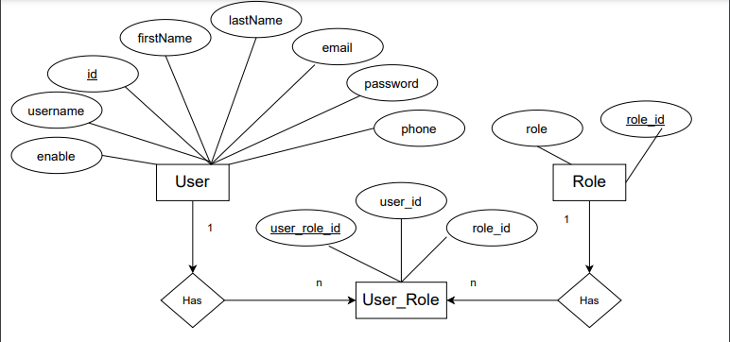

Figure 10.2(a)

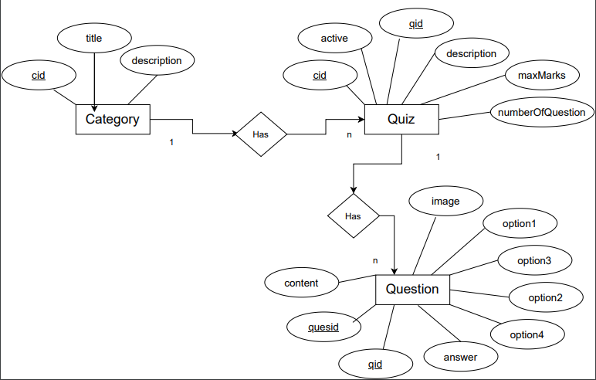

Figure 10.2(b)

**(10.3)Activity Diagram:**

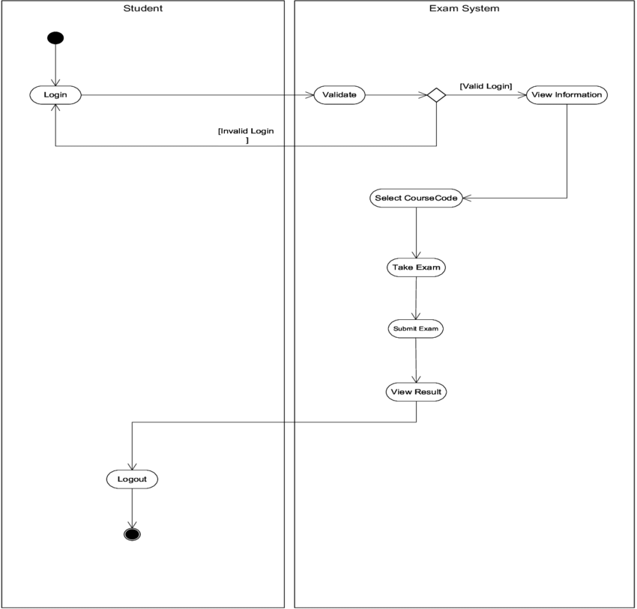

Figure 10.3

**(10.4) Class Diagram:**

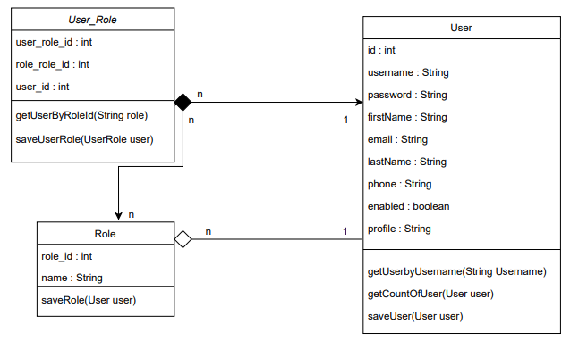

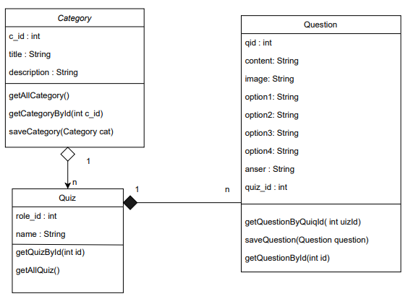

Figure 10.4

**(10.5) State Diagram:**

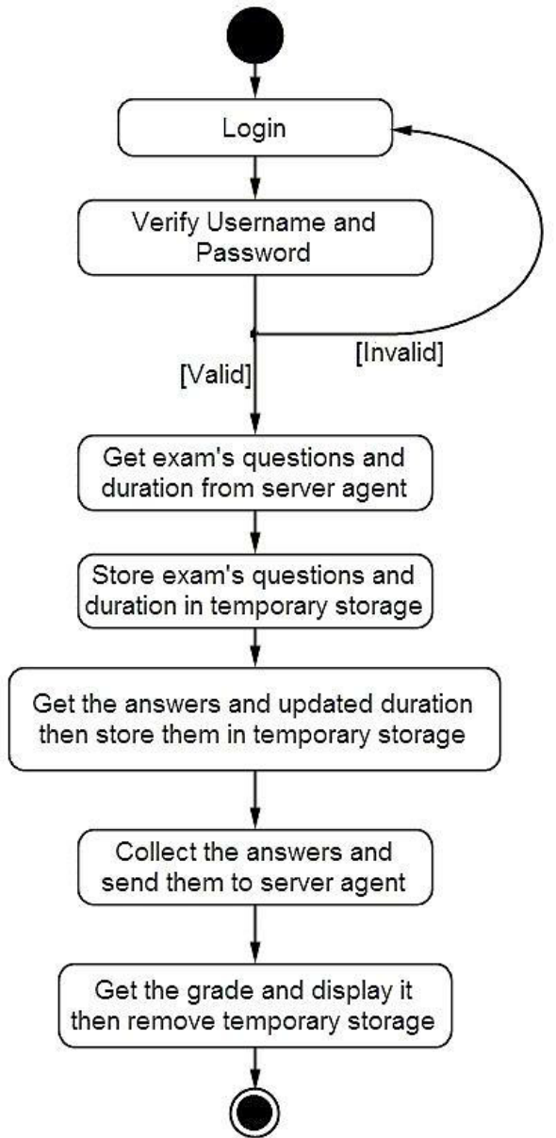

Figure 10.5

**(11)Database Design**

**(11.1)User Module Schema**

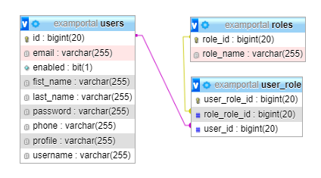

Figure 11.4

**(11.2)Exam Module Schema**

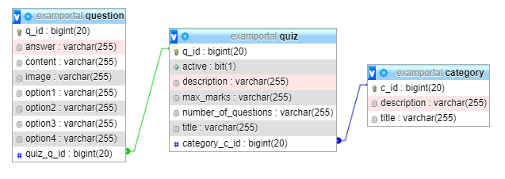

Figure 11.2

**(11.3)Database Table**

**(11.3.1) User Table :**

|  |  |  |  |
| --- | --- | --- | --- |
| **Column** | **Type** | **Null** | **Description** |
| Id | bigint(20) | Primary Key | Primary key of the table |
| username | varchar(255) | No | Username |
| password | varchar(255) | No | Password |
| firstName | varchar(255) | No | First name of the user |
| lastName | varchar(255) | No | Last name of the user |
| Email | varchar(255) | No | Email of the user |
| Phone | varchar(255) | No | Mobile number |
| enabled | varchar(255) | No | Is user is active or not |
| profile | varchar(255) | No | Profile photo of user |

**(11.3.2) Role Table**

|  |  |  |  |
| --- | --- | --- | --- |
| **Column** | **Type** | **Null** | **Description** |
| Role_id | bigint(20) | Primary Key | Primary key of the table |
| Role_name | varchar(255) | No | Role name |

**(11.3.3) User_role**

|  |  |  |  |
| --- | --- | --- | --- |
| **Column** | **Type** | **Null** | **Description** |
| User_role_id | bigint(20) | Primary Key | Primary key of the table |
| Role_role_id | bigint(20) | Foreign Key | Foreign key of Role Table |
| User_id | bigint(20) | Foreign Key | Foreign key of User Table |

**(11.3.4) Category Table**

|  |  |  |  |
| --- | --- | --- | --- |
| **Column** | **Type** | **Null** | **Description** |
| C_id | bigint(20) | Primary Key | Primary key of the table |
| Title | Varchar(255) | No | Title of the category |
| description | Varchar(1000) | No | Description of the category |

**(11.3.5) Quiz Table**

|  |  |  |  |
| --- | --- | --- | --- |
| **Column** | **Type** | **Null** | **Description** |
| q_id | bigint(20) | Primary Key | Primary key of the table |
| Title | Varchar(400) | No | Title of the quiz |
| description | Varchar(1000) | No | Description of the category |
| no_of_question | Varchar(255) | No | No of Question |
| max_marks | Varchar(255) | No | Max Mark of Question |
| active | boolean | No | State of Question |
| category_c_id | Varchar(255) | Foreign Key | Foreign Key of Category Table |

**(11.3.6) Question Table**

|  |  |  |  |
| --- | --- | --- | --- |
| **Column** | **Type** | **Null** | **Description** |
| q_id | bigint(20) | Primary Key | Primary key of the table |
| Content | Varchar(400) | No | Content of the Question |
| Option1 | Varchar(255) | No | Option for Question |
| Option2 | Varchar(255) | No | Option for Question |
| Option3 | Varchar(255) | No | Option for Question |
| Option4 | Varchar(255) | No | Option for Question |
| Answer | Varchar(255) | No | Answer of Quetion |
| Image | Varchar(255) | No | Image If Any In Quetion |
| Quiz_q_id | bigint(20) | Foreign Key | Foreign Key Of Quiz Table |

**(12) Implementation methodology**

**We are used waterfall model here to develop Exam portal application.**

Many consider the waterfall method to be the most traditional software development method. The waterfall method is a rigid linear model that consists of sequential phases (requirements, design, implementation, verification, maintenance) focusing on distinct goals. Each phase must be 100% complete before the next phase can start. There’s usually no process for going back to modify the project or direction.

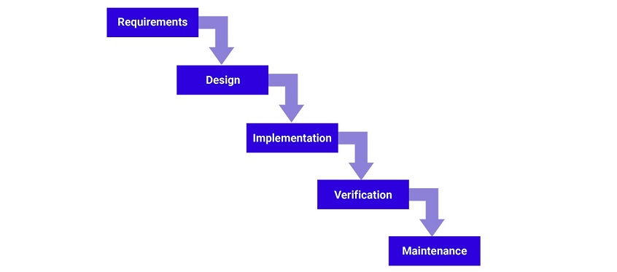

Figure 12

**(13) List of reports that are likely to be generated**

* **Student Mock Text Report Will Be Generated.**
* **Category Of Mock Text Wise Report Of Students**
* **Grade Wise Report Of Student**

**(14)Process Logic**

**(14.1) Login**

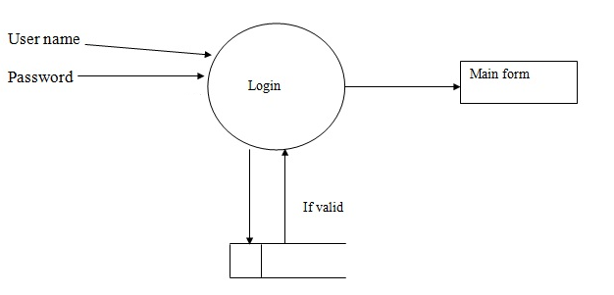

Figure 14.1

**(14.2) Registration**

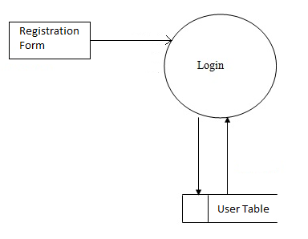

Figure 14.2

**(15) Implementation of security mechanisms at various levels**

* **Spring Security** is a powerful and highly customizable authentication and access-control framework. It is the de-facto standard for securing Spring-based applications. Spring Security is a framework that focuses on providing both authentication and authorization to Java applications. Like all spring projects, the real power of Spring Security is found in how easily it can be extended to meet custom requirements
* **JSON Web Token (JWT)** is an open standard ([RFC 7519](https://tools.ietf.org/html/rfc7519)) that defines a compact and self-contained way for securely transmitting information between parties as a JSON object. This information can be verified and trusted because it is digitally signed. JWTs can be signed using a secret (with the **HMAC** algorithm) or a public/private key pair using **RSA** or **ECDSA**.

* **Angular Security** **Features**: Angular recognizes the value as unsafe and automatically sanitizes it, which removes the script element but keeps safe content such as the <b> element.

Direct use of the DOM APIs and explicit sanitization call slink. ...

* + Trusting safe values link.
  + Content security policy link.
  + Use the AOT template compiler link

**(16) Future Enhancement**

This application is very helpful those people who doesn’t know, how the online

Examination are conducted. This will give a better experience to the user for any professional

Certification online exam Or Mock Tests.

As per future of information technology all educational and professional, industrial work are going to shift on internet as per requirement Exam portal application gives very good way to conduct examination in online mode.

**(17) Bibliography**

* **For Back End**

* <https://www.javatpoint.com>
* <https://spring.io/>
* <https://www.tutorialpoint.com>
* <https://docs.oracle.com/en/java/javase/11/>
* **For Front End**
* <https://www.angular.io/>
* <https://www.tutorialpoint.com>
* <https://www.javatpoint.com>
* **For Database**
* <https://www.tutorialpoint.com>
* <https://www.javatpoint.com>
* <https://dev.mysql.com/doc/>